### **Project is from Page 15**

### **1. Global Environment Variables**

When you define environment variables globally in Jenkins (via Manage Jenkins > Configure System), they are available to all jobs and pipelines running on the Jenkins instance. These variables are fetched by Jenkins and injected into the pipeline’s environment.

**How It Works**:

* **Configuration**: You define global environment variables in the Jenkins global configuration page.
* **Pipeline Access**: In the Jenkinsfile, you can access these variables directly by their names. Jenkins resolves these names to their values during runtime.

**Example**: If you define MAVEN_HOME globally:

* Name: MAVEN_HOME
* Value: /usr/local/maven

In the Jenkinsfile:

sh "${env.MAVEN_HOME}/bin/mvn clean install"

Jenkins replaces ${env.MAVEN_HOME} with /usr/local/maven.

### **2. Environment Variables in Pipeline Job Configuration**

When you define environment variables within a specific pipeline job’s configuration:

* **Configuration**: You add environment variables under the job configuration or in the pipeline's environment block.
* **Pipeline Access**: These variables are available only to that specific job or pipeline.

**Example in Pipeline Job Configuration**: If you define DEPLOY_SERVER and DEPLOY_PATH in the pipeline configuration:

* Name: DEPLOY_SERVER
* Value: your-server
* Name: DEPLOY_PATH
* Value: /path/to/deploy

In the Jenkinsfile:

sh "scp target/${env.APP_NAME}.jar user@${env.DEPLOY_SERVER}:${env.DEPLOY_PATH}"

### **Multi-Branch Pipelines**

A Multi-Branch Pipeline in Jenkins is a powerful feature that allows you to automatically create and manage Jenkins pipelines for multiple branches in a repository. This setup is highly useful for projects with multiple branches like development, feature, and production branches. Each branch can have its own pipeline configuration based on the Jenkinsfile present in that branch.

#### **Key Features**

1. **Automatic Branch Discovery**: Jenkins automatically discovers branches with a Jenkinsfile in your repository and creates pipeline jobs for them.
2. **Branch-Specific Pipelines**: Each branch can have its own pipeline configuration, allowing you to customize the CI/CD process per branch.
3. **PR and Merge Requests**: Jenkins can handle pull requests or merge requests, running pipelines on code changes before merging.

### **Use Cases**

#### **1. Feature Branches**

**Use Case**: Run tests and builds for feature branches to ensure code quality before merging into the main branch.

**Example Jenkinsfile**:

pipeline {

agent any

stages {

stage('Checkout') {

steps {

git url: 'https://github.com/your-repo/your-project.git', branch: env.BRANCH_NAME

}

}

stage('Build') {

steps {

script {

echo "Building feature branch: ${env.BRANCH_NAME}"

withMaven(maven: 'Maven-3.9.0') {

sh 'mvn clean package'

}

}

}

}

stage('Test') {

steps {

script {

echo "Running tests on feature branch: ${env.BRANCH_NAME}"

withMaven(maven: 'Maven-3.9.0') {

sh 'mvn test'

}

}

}

}

}

post {

always {

echo 'Pipeline finished.'

}

success {

echo 'Pipeline succeeded.'

}

failure {

echo 'Pipeline failed.'

}

}

}

**Explanation**: This pipeline checks out the code from a feature branch, builds it using Maven, and runs tests. Each feature branch will trigger this pipeline automatically when changes are pushed.

#### **2. Development Branches**

**Use Case**: Run integration tests and static analysis tools on development branches to ensure code quality and integration before moving to staging or production.

**Example Jenkinsfile**:

pipeline {

agent any

stages {

stage('Checkout') {

steps {

git url: 'https://github.com/your-repo/your-project.git', branch: env.BRANCH_NAME

}

}

stage('Build') {

steps {

script {

echo "Building development branch: ${env.BRANCH_NAME}"

withMaven(maven: 'Maven-3.9.0') {

sh 'mvn clean package'

}

}

}

}

stage('Integration Test') {

steps {

script {

echo "Running integration tests on development branch: ${env.BRANCH_NAME}"

withMaven(maven: 'Maven-3.9.0') {

sh 'mvn verify'

}

}

}

}

stage('Static Analysis') {

steps {

script {

echo "Performing static analysis on development branch: ${env.BRANCH_NAME}"

sh 'mvn pmd:pmd'

}

}

}

}

post {

always {

echo 'Pipeline finished.'

}

success {

echo 'Pipeline succeeded.'

}

failure {

echo 'Pipeline failed.'

}

}

}

**Explanation**: This pipeline is set up for development branches and includes additional stages for integration testing and static analysis.

#### **3. Master/Production Branch**

**Use Case**: Deploy code from the master branch to production after successful builds and tests.

**Example Jenkinsfile**:

pipeline {

agent any

stages {

stage('Checkout') {

steps {

git url: 'https://github.com/your-repo/your-project.git', branch: env.BRANCH_NAME

}

}

stage('Build') {

steps {

script {

echo "Building production branch: ${env.BRANCH_NAME}"

withMaven(maven: 'Maven-3.9.0') {

sh 'mvn clean package'

}

}

}

}

stage('Deploy') {

when {

branch 'master'

}

steps {

script {

echo "Deploying to production from branch: ${env.BRANCH_NAME}"

sh 'deploy.sh'

}

}

}

}

post {

always {

echo 'Pipeline finished.'

}

success {

echo 'Pipeline succeeded.'

}

failure {

echo 'Pipeline failed.'

}

}

}

**Explanation**: This pipeline specifically deploys code from the master branch. The when directive ensures that the deploy step is executed only for the master branch.

#### **4. Pull Request Branches**

**Use Case**: Run a pipeline for pull requests to validate code changes before they are merged into the main branches.

**Example Jenkinsfile**:

pipeline {

agent any

stages {

stage('Checkout') {

steps {

git url: 'https://github.com/your-repo/your-project.git', branch: env.CHANGE_BRANCH

}

}

stage('Build') {

steps {

script {

echo "Building pull request branch: ${env.CHANGE_BRANCH}"

withMaven(maven: 'Maven-3.9.0') {

sh 'mvn clean package'

}

}

}

}

stage('Test') {

steps {

script {

echo "Running tests on pull request branch: ${env.CHANGE_BRANCH}"

withMaven(maven: 'Maven-3.9.0') {

sh 'mvn test'

}

}

}

}

}

post {

always {

echo 'Pipeline finished.'

}

success {

echo 'Pipeline succeeded.'

}

failure {

echo 'Pipeline failed.'

}

}

}

**Explanation**: This pipeline handles pull requests, checking out the branch associated with the pull request (CHANGE_BRANCH), building it, and running tests.

### **Multi-Branch Pipeline for a Simple Java Maven Project**

#### **1. Setup the Project Repository**

Let's assume you have a Git repository with a Java Maven project. Here’s a simple example of the project structure:

my-java-app/

├── pom.xml

└── src

└── main

└── java

└── com

└── example

└── App.java

**pom.xml**

<?xml version="1.0" encoding="UTF-8"?>

<project xmlns="http://maven.apache.org/POM/4.0.0"

xmlns:xsi="http://www.w3.org/2001/XMLSchema-instance"

xsi:schemaLocation="http://maven.apache.org/POM/4.0.0 http://maven.apache.org/POM/4.0.0/maven-4.0.0.xsd">

<modelVersion>4.0.0</modelVersion>

<groupId>com.example</groupId>

<artifactId>my-java-app</artifactId>

<version>1.0-SNAPSHOT</version>

<properties>

<maven.compiler.source>1.8</maven.compiler.source>

<maven.compiler.target>1.8</maven.compiler.target>

</properties>

</project>

**App.java**

package com.example;

public class App {

public static void main(String[] args) {

System.out.println("Hello, Maven!");

}

}

#### **2. Create Branches**

Create different branches to demonstrate the multi-branch pipeline functionality:

cd my-java-app

git init

git add .

git commit -m "Initial commit"

git branch feature-branch-1

git branch feature-branch-2

git checkout feature-branch-1

# Modify App.java for feature-branch-1

echo "System.out.println(\"Feature Branch 1!\");" > src/main/java/com/example/App.java

git add src/main/java/com/example/App.java

git commit -m "Update App.java in feature-branch-1"

git push -u origin feature-branch-1

git checkout feature-branch-2

# Modify App.java for feature-branch-2

echo "System.out.println(\"Feature Branch 2!\");" > src/main/java/com/example/App.java

git add src/main/java/com/example/App.java

git commit -m "Update App.java in feature-branch-2"

git push -u origin feature-branch-2

#### **3. Create a Jenkinsfile**

Create a Jenkinsfile in the root of your repository. This file defines how Jenkins will build and test your application.

**Jenkinsfile**

pipeline {

agent any

stages {

stage('Build') {

steps {

echo 'Building the Java application...'

sh 'mvn clean package'

}

}

stage('Test') {

steps {

echo 'Running tests...'

// Add your test commands here if you have tests

}

}

}

post {

success {

echo 'Build and test succeeded!'

}

failure {

echo 'Build or test failed!'

}

}

}

#### **4. Configure Jenkins**

1. **Install Required Plugins** Ensure Jenkins has the following plugins installed:
   * **Git Plugin**: To pull code from Git repositories.
   * **Pipeline Plugin**: To support pipeline jobs.
   * **Multi-Branch Pipeline Plugin**: To support multi-branch pipelines.
2. **Create a Multi-Branch Pipeline Job**
   * Go to Jenkins Dashboard.
   * Click on New Item.
   * Enter a name for your job (e.g., MyJavaApp-MultiBranch).
   * Select Multi-branch Pipeline and click OK.
3. **Configure the Multi-Branch Pipeline Job**
   * **Branch Sources**:
     + Add a source for your Git repository.
     + Configure the repository URL and credentials (if required).
   * **Build Configuration**:
     + Jenkins will automatically scan branches for Jenkinsfile and create a pipeline for each branch.
4. **Set Up Webhooks (Optional but Recommended)**
   * To trigger builds automatically when code is pushed to the repository, configure a webhook in your Git repository that points to your Jenkins server.

#### **5. Run and Monitor**

* Jenkins will scan your repository and create pipelines for each branch with a Jenkinsfile.
* For each branch, Jenkins will execute the pipeline defined in Jenkinsfile and provide build statuses.

### **Understanding Docker Image Layers**

1. **Base Layer**: The starting point of your Docker image, typically an official or minimal base image (e.g., alpine, ubuntu).
2. **Intermediate Layers**: Each instruction in your Dockerfile (e.g., RUN, COPY, ADD) adds a new layer on top of the previous ones.
3. **Final Layer**: The result of the final instruction in your Dockerfile.

### **Optimizing Docker Image Layers**

**Choose a Small Base Image**: Start with a minimal base image like alpine, scratch, or other lightweight images instead of full-blown OS images like ubuntu.  
  
FROM alpine:latest

**Combine Instructions**: Minimize the number of layers by combining multiple RUN commands into a single instruction. Use && to chain commands together.  
  
# Less optimal

RUN apt-get update

RUN apt-get install -y package1

RUN touch file1 && rm file1

RUN apt-get install -y package2

# More optimal

RUN apt-get update && apt-get install -y package1 package2 && rm -rf /var/lib/apt/lists/*

**Clean Up Intermediate Files**: Remove temporary files and caches within the same RUN instruction to prevent them from being saved as layers.  
  
RUN apt-get update && \

apt-get install -y package1 package2 && \

rm -rf /var/lib/apt/lists/*

**Use Multi-Stage Builds**: Multi-stage builds allow you to use a temporary image to build your application and then copy only the necessary artifacts to a smaller runtime image.  
  
# First stage

FROM golang:alpine AS build

WORKDIR /app

COPY . .

RUN go build -o myapp

# Second stage

FROM alpine:latest

WORKDIR /app

COPY --from=build /app/myapp .

CMD ["./myapp"]

**Avoid Installing Unnecessary Packages**: Only install the packages and dependencies you need.  
  
RUN apt-get update && \

apt-get install -y --no-install-recommends package1 package2 && \

rm -rf /var/lib/apt/lists/*

**Minimize the Number of Layers**: Each RUN, COPY, and ADD instruction creates a new layer. Minimize the number of these instructions.  
  
# Less optimal

COPY . /app

RUN cd /app && make

# More optimal

COPY . /app && cd /app && make

**Use .dockerignore File**: Similar to .gitignore, use .dockerignore to exclude files and directories that are not needed in the final image, reducing the context sent to the Docker daemon.  
plaintext  
Copy code  
node_modules

*.log

1. **Optimize the Application**: Optimize your application itself to reduce its size, such as compressing assets and removing unnecessary files.

### **Example Dockerfile Optimization**

Before Optimization:

FROM ubuntu:latest

RUN apt-get update

RUN apt-get install -y python3 python3-pip

COPY . /app

WORKDIR /app

RUN pip3 install -r requirements.txt

CMD ["python3", "app.py"]

After Optimization:

FROM python:3.9-slim

WORKDIR /app

COPY requirements.txt .

RUN pip install --no-cache-dir -r requirements.txt

COPY . .

CMD ["python", "app.py"]

### **Multi-Branch Project**

#### **Project Overview**

* Create a simple Java Maven project.
* Version-control the project using Git with multiple branches.
* Set up Jenkins multi-branch pipeline for automated build and deployment.
* Utilize Jenkins environment variables in the Jenkinsfile.

#### **Project Objectives**

* Version-control using Git.
* Jenkins multi-branch pipeline setup.
* Environment variable management using Jenkinsfile.

#### **Project Deliverables**

1. **Git Repository:**
   * Local Git repository initialized.
   * Branches: development, staging, and production.
   * Repository pushed to remote Git server (e.g., GitHub, GitLab, Bitbucket).

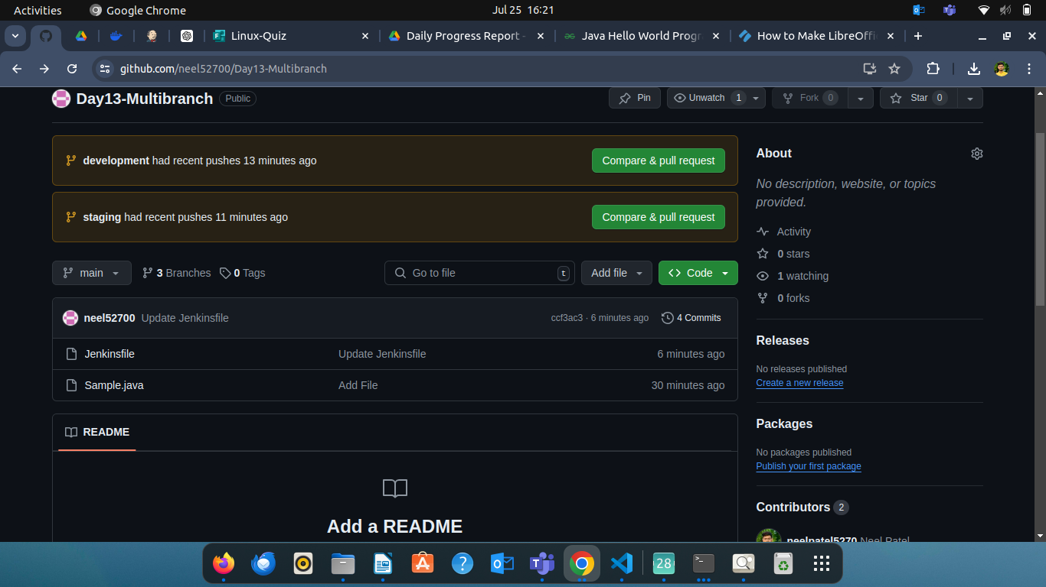**Step 1**

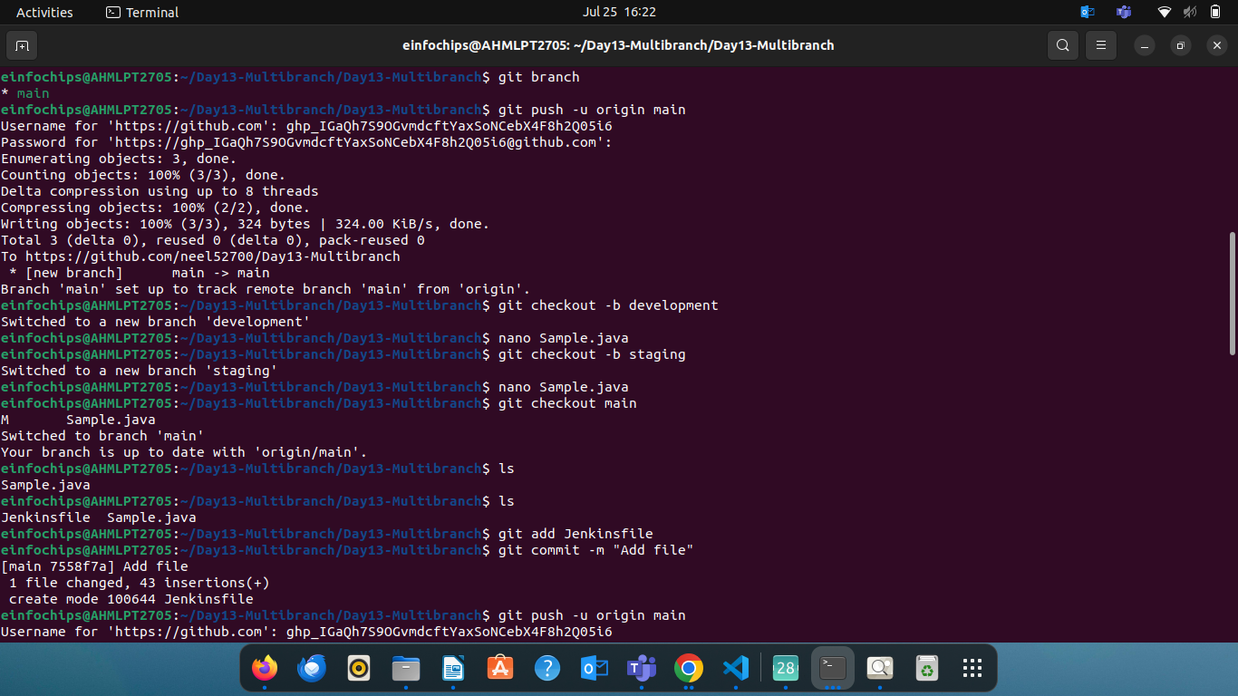

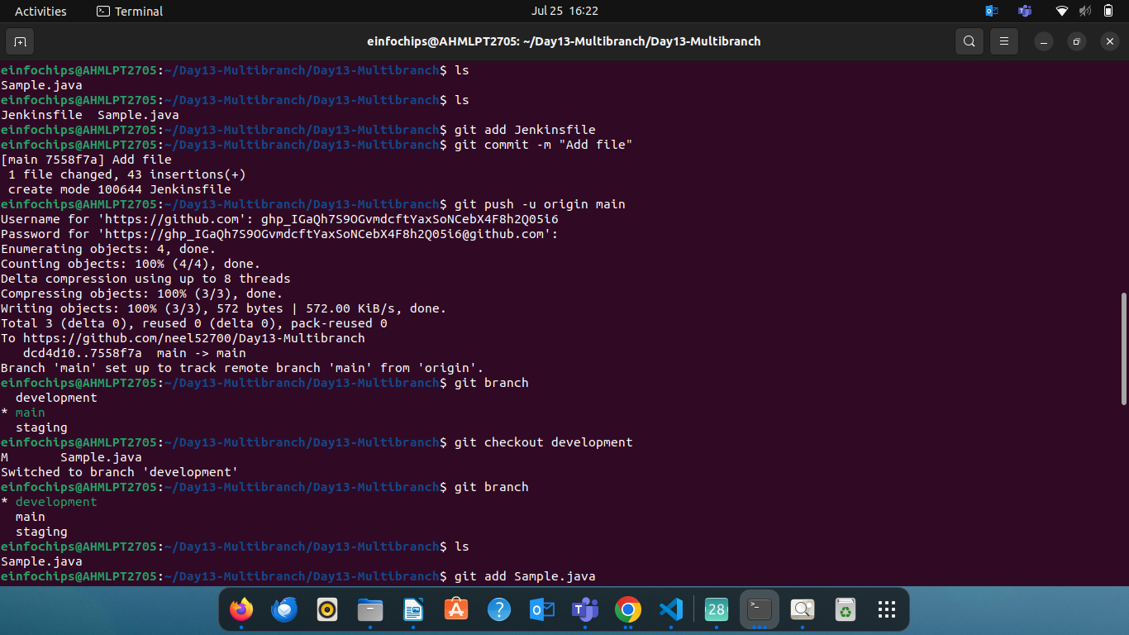

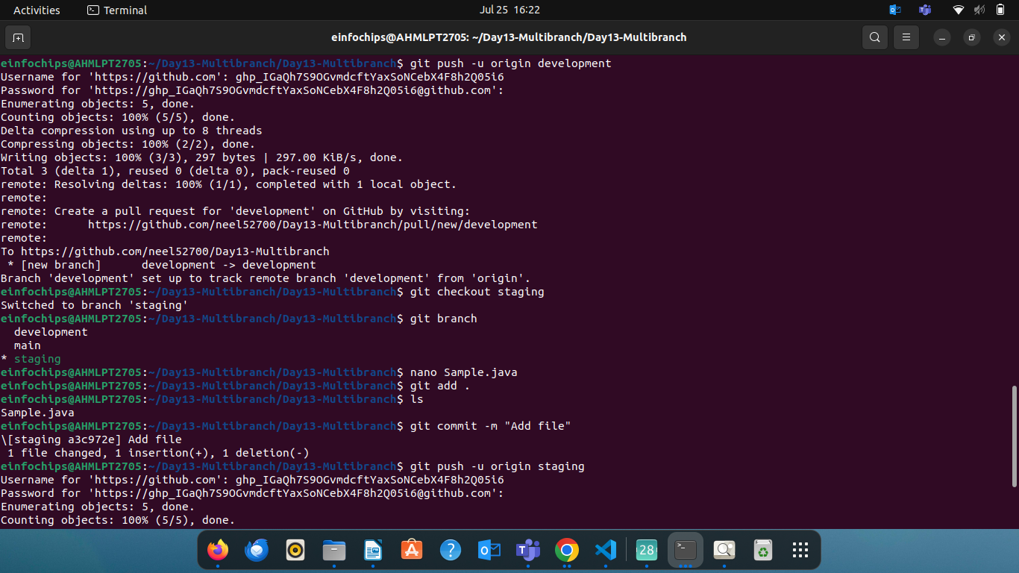

* Initialize Local Git Repository
* Create Branches
* Create a Simple Java Project on main branch
* Push to Remote Git Server

Add the remote repository

Push branches to the remote repository

* Create a jenkins file on main branch

1. **Maven Project:**
   * Simple Java Maven project created (HelloWorld application).
   * pom.xml with dependencies and build configurations.

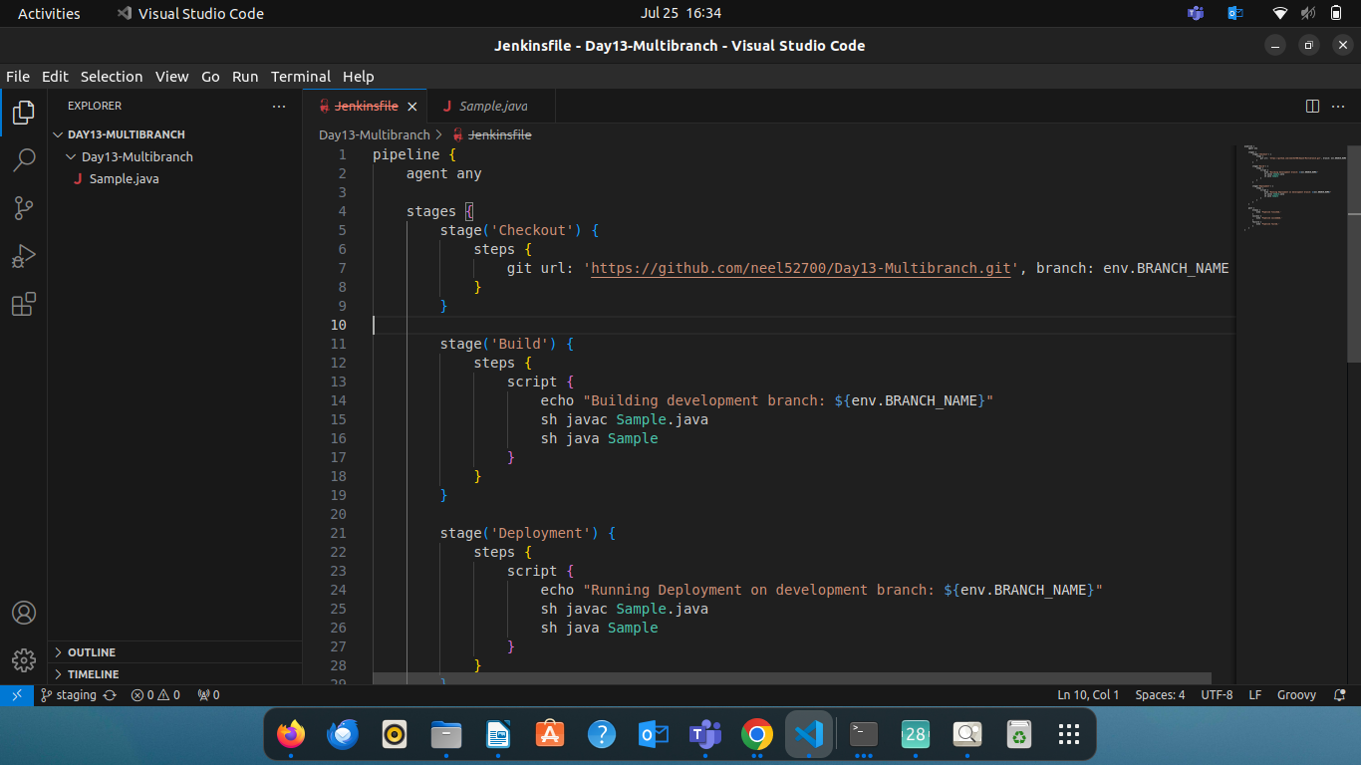

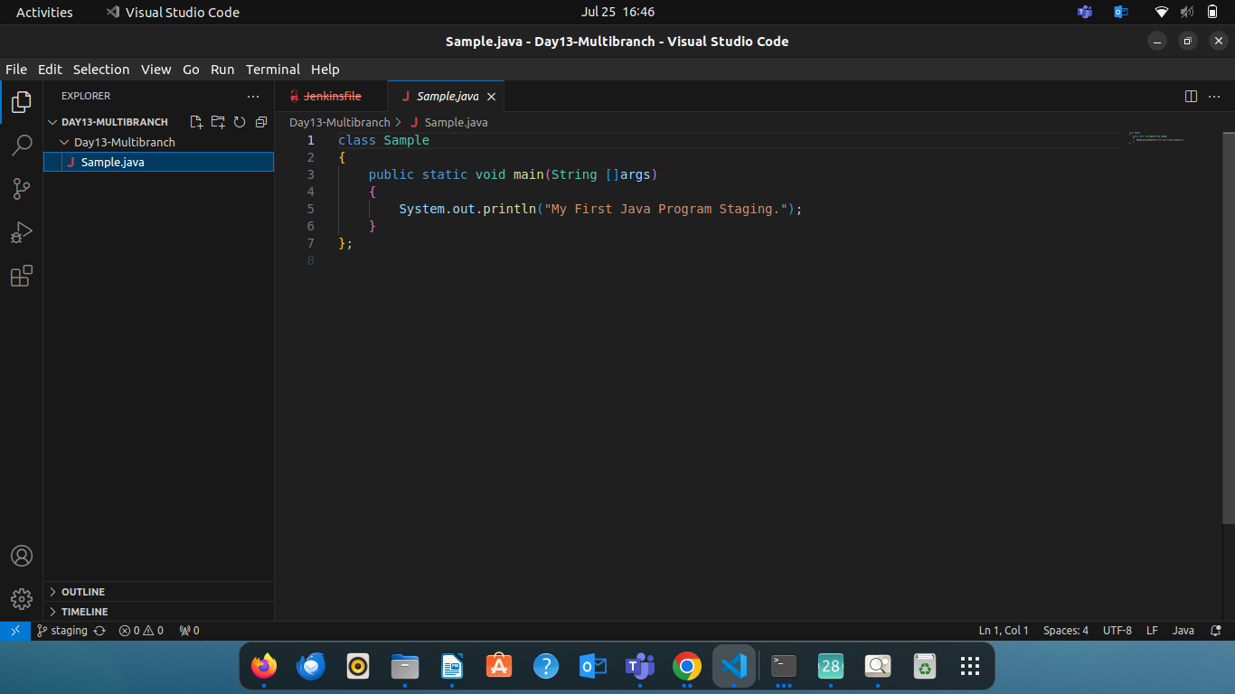

1. **Jenkins Setup:**
   * Multi-branch pipeline job configured in Jenkins.
   * Jenkinsfile defining build and deployment steps.
   * Environment variables managed using Jenkins environment variable settings.

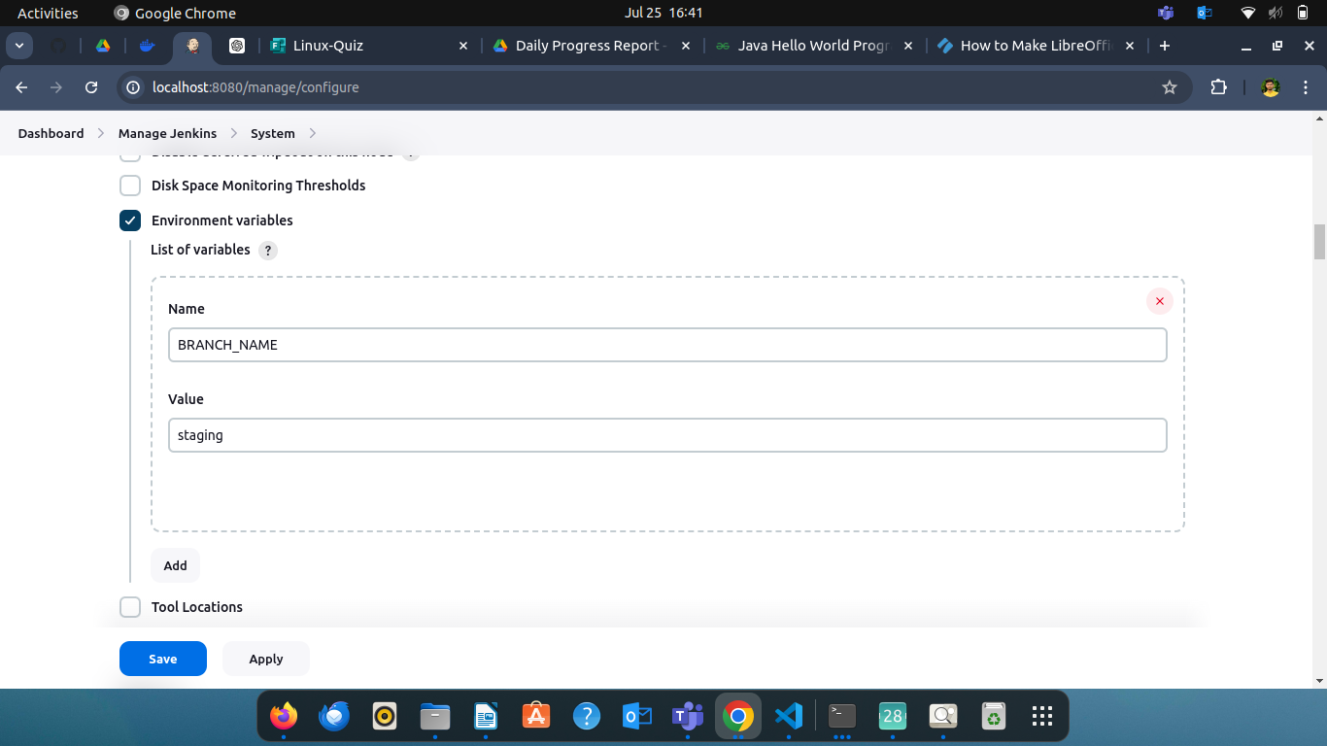

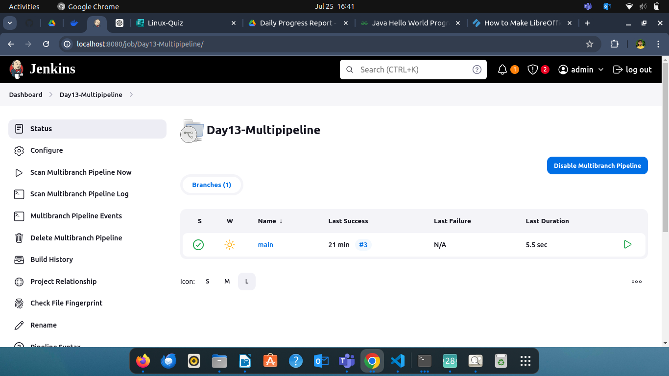

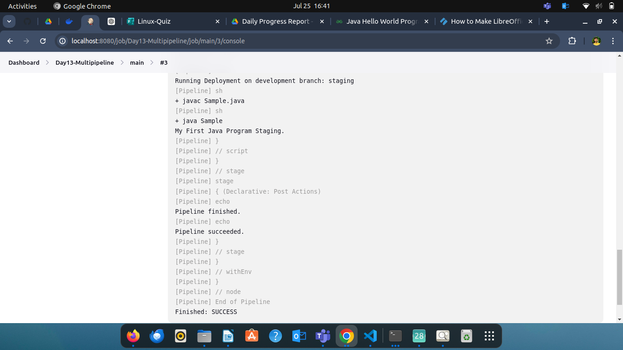

* Trigger the Pipeline Manually:
* Go to Jenkins dashboard.
* Select the pipeline job.
* Click on "Build Now".
* Monitor the Build Process:
  + Open the build details in Jenkins.
  + Check the console output to monitor the progress and status of each stage.